Yifu He 10442277

Q1:

the time series plot of the expected sigma using the method of EWMA

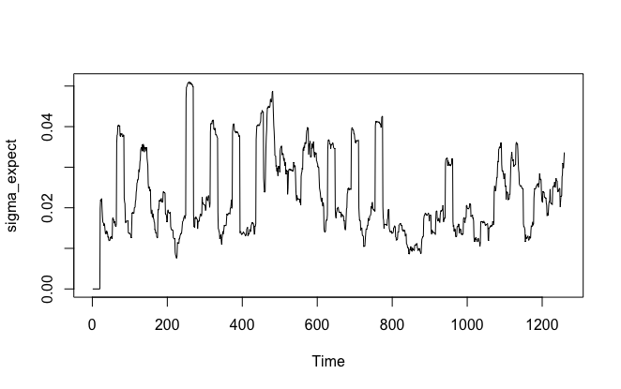Q2:

Use the Roll’s model to estimate the fundamental volatility

The total fundamental volatility of 5 years is Sigma_mu = 4.313382.

The 20 days fundamental volatility time series of the stock in 5 years is this:

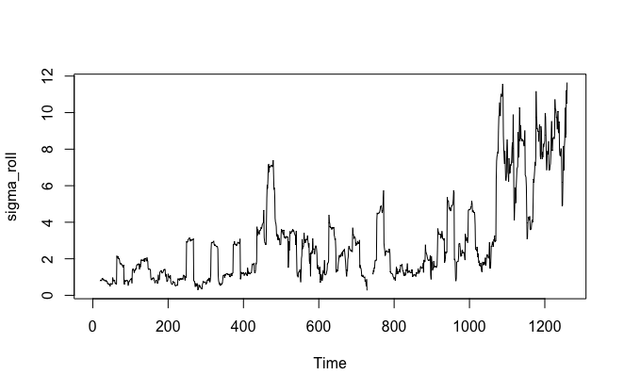

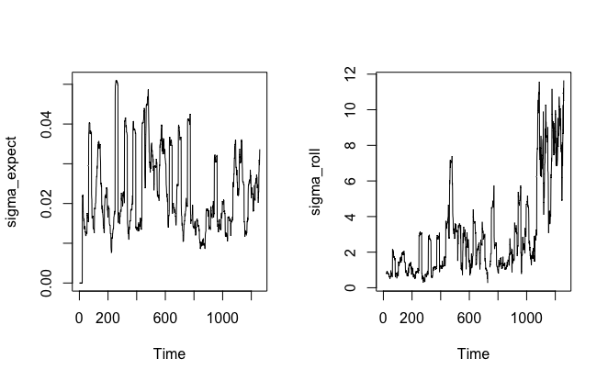

They both reflected the fluctuation of the asset prices

Source code:

getwd()

setwd("/Users/yifuhe/Desktop")

mydata <- read.csv("NFLX-2013_2018.csv")

###Q1

n <- 20

beta <- 2/(n+1)

price <- unlist(mydata[6])

log_r <-c(NA)

log_r[1] <- 0

for (i in 2:length(price)){log_r[i] <- log(price[i])-log(price[i-1])}

## create sigma_ori

sigma_ori <- c(NA)

for (i in seq(n)){

sigma_ori[i] <- 0

}

for (i in n:length(price)){

r_mean <- mean(log_r[(i-n+1):i])

sum <-0

for (j in 1:n){

sum=sum + (log_r[i-n+j] - r_mean)^2

}

sigma_ori[i]<-sqrt(sum/n)

}

## create sigma

sigma_expect <- c(NA)

for (i in seq(n)){

sigma_expect[i] <- 0

}

down_sub <- 0

for (i in 1:n){

down_sub <- down_sub + beta^i

}

for (i in (n+1):length(sigma_ori)){

total <- 0

for (j in seq(n)){

total <- total+ (beta^j)*sigma_ori[i-j]/down_sub

}

sigma_expect[i] <- total

}

## create the plot of sigma_expect

ts.plot(sigma_expect)

##Question3

gamma<-acf(diff(price),type="covariance",lag.max=1,plot=FALSE)

gamma0<-gamma$acf[1]

gamma1<-gamma$acf[2]

sigma_u<-sqrt(gamma0+2*gamma1)

sigma_u

##question3

sigma_roll <- c(NA)

for (i in n:(length(price))){

gamma<-acf(diff(price[(i-n+1):(i)]),type="covariance",lag.max=1,plot=FALSE)

gamma0<-gamma$acf[1]

gamma1<-gamma$acf[2]

sigma_u<-sqrt(gamma0+2*gamma1)

sigma_roll[i] <-sigma_u

}

par

ts.plot(sigma_roll)